**Data Visualization Using Tableau - 2**

**Assignment – 2**

**Student Personal Information**

**Report**

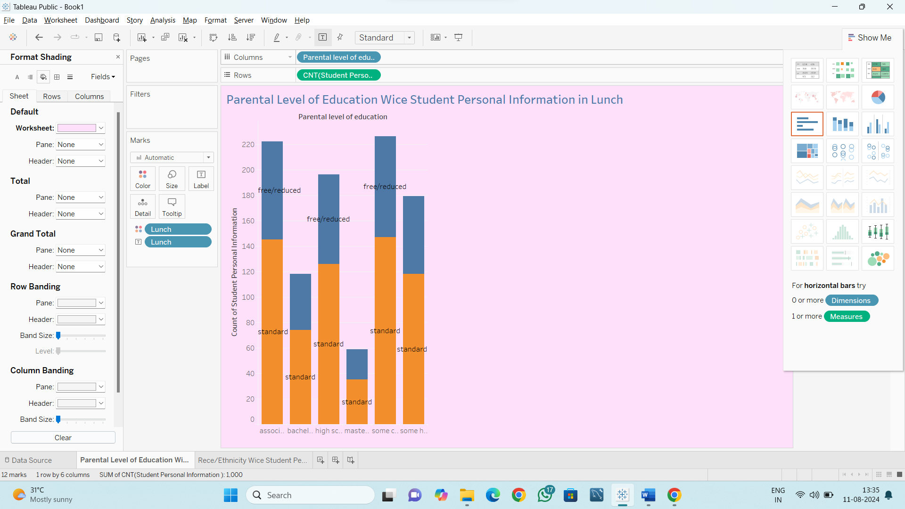

**Dashboard**

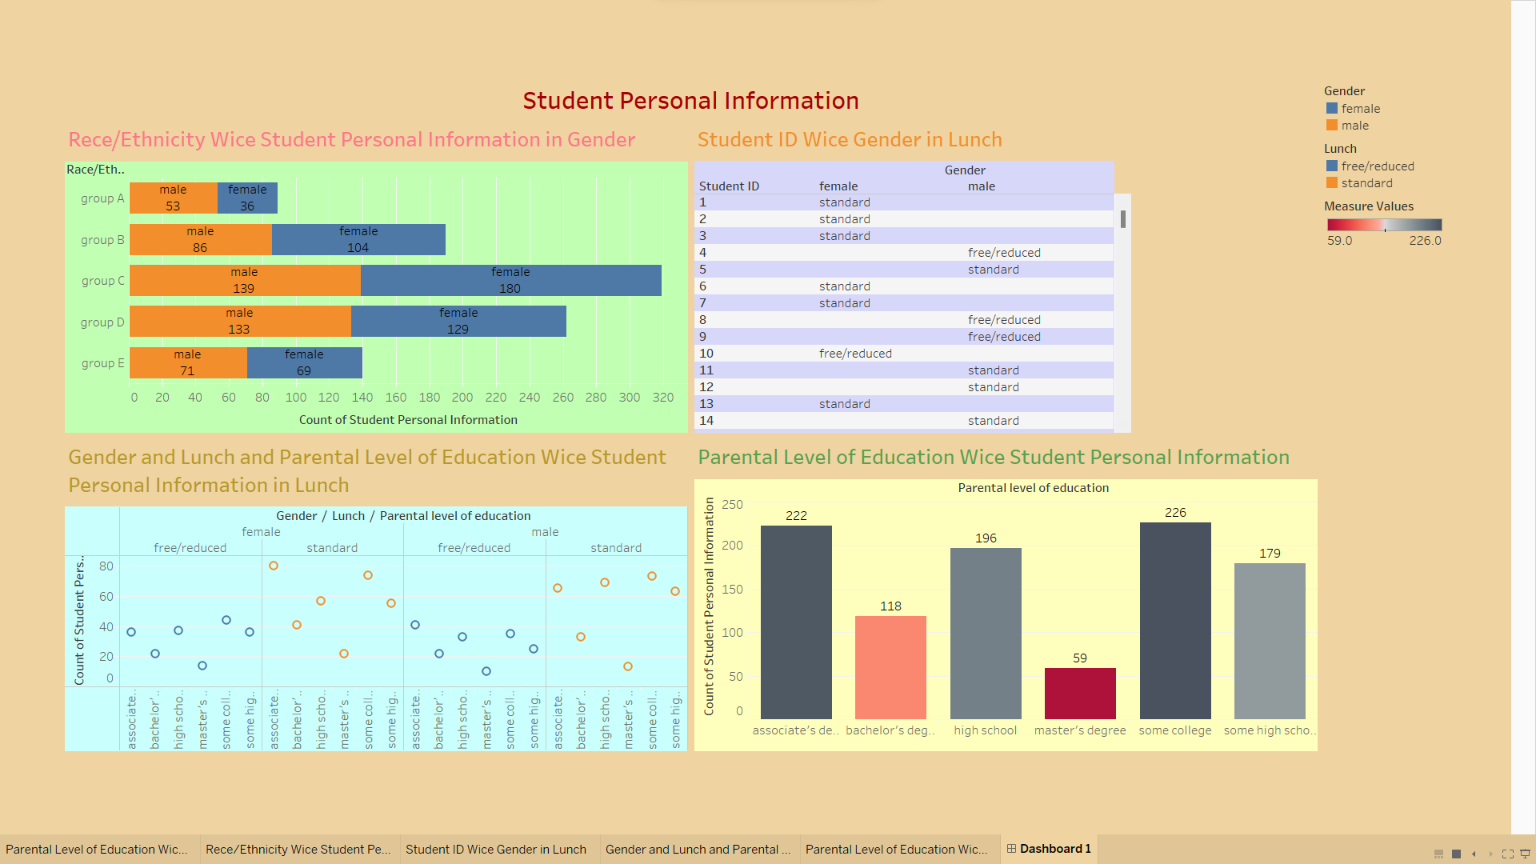

**Assignment – 3**

**Student Academic Information**

**Report**

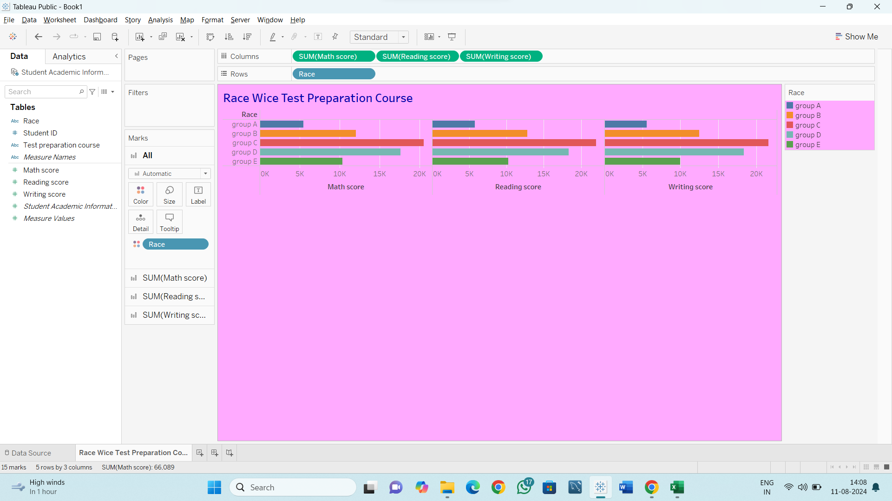

**Dashboard**

